Thadomal Shahani Engineering College, Bandra
Department of Artificial Intelligence & Data Science
Experiment 04
Name: Bhavisha d Kewalramani Subject:ASD&D LAB
Batch:T12 Roll no:2401044

Aim: To understand continuous integration, Jenkins installation
This experiment maps to LO1,LO3:

LO1:Apply Agile methodologies and use JIRA for sprint planning, task tracking and integrating
DevOp workflows
LO3:Build and Manage automated CI/CD Pipeline for application development, testing, packaging, and deployment.

Theory:

Jenkins
Jenkins is a free and open-source automation server widely used to implement Continuous Integration (CI) and Continuous Delivery/Deployment (CD) in software development. It automates repetitive tasks such as compiling source code, executing automated tests, generating reports, packaging applications, and deploying software to different environments. By automating these processes, Jenkins helps improve software quality, reduces manual effort, and accelerates the development lifecycle.
Jenkins integrates with a wide range of development tools, including Git, Maven, Gradle, JUnit, Docker, Kubernetes, and various cloud platforms through its extensive plugin library. It is built using Java and runs on the Java Virtual Machine (JVM). Jenkins also provides a web-based interface that allows developers to configure jobs, monitor builds, manage users, install plugins, and create automated pipelines.

Jenkins Pipeline
A Jenkins Pipeline is a sequence of automated tasks that defines the complete software delivery workflow. The pipeline is written as code in a file called a Jenkinsfile, allowing the entire build and deployment process to be version-controlled along with the application source code. This approach improves consistency, maintainability, and collaboration among development teams.
A typical Jenkins pipeline consists of the following stages:
- Build – Compiles the application's source code and creates executable files or packages. ● Test – Executes automated tests to verify the application's functionality, quality, and reliability.
- Deploy – Deploys the successfully tested application to a testing, staging, or production environment.

Advantages of Jenkins Pipeline
- Automates the entire software development and deployment process.
- Minimizes human intervention and reduces manual errors.
- Speeds up code integration, testing, and software delivery.
- Provides clear visibility into each stage of the build process.
- Supports Continuous Integration (CI) and Continuous Deployment (CD) practices. ● Stores pipeline configurations as code, making them easy to maintain, share, and version-control.

Types of Jenkins Pipelines

1. Declarative Pipeline
The Declarative Pipeline is the recommended and most commonly used pipeline syntax in Jenkins. It follows a structured format using the pipeline {} block, making the pipeline easier to understand, write, and maintain. Due to its simple and organized syntax, it is especially suitable for beginners and teams that prefer a standardized pipeline structure.
Features:
- Uses the pipeline {} syntax.
- Provides a simple and well-defined structure.
- Easier to read, write, and maintain.
- Ideal for beginners and standard CI/CD workflows.
Example:
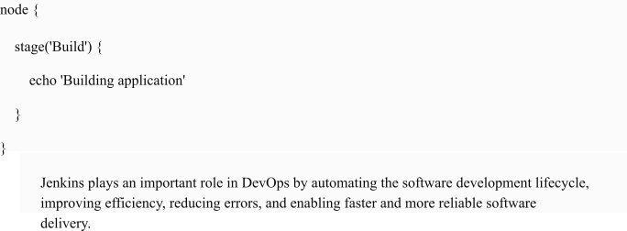
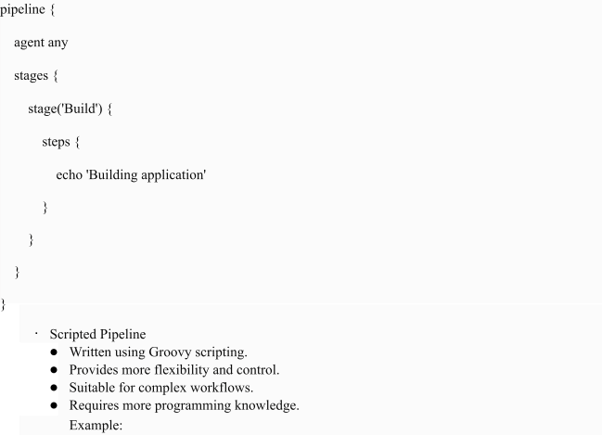

Implementation

- Check if JDK (Java Development Kit) is installed.

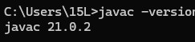

- Download Jenkins WAR file from official website or packet manager

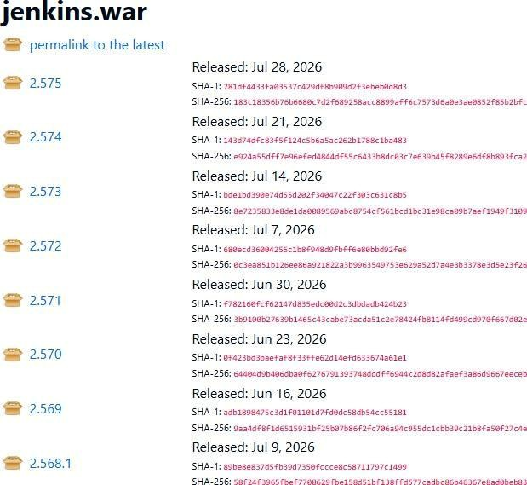
- Launch command prompt on your system and give the following command

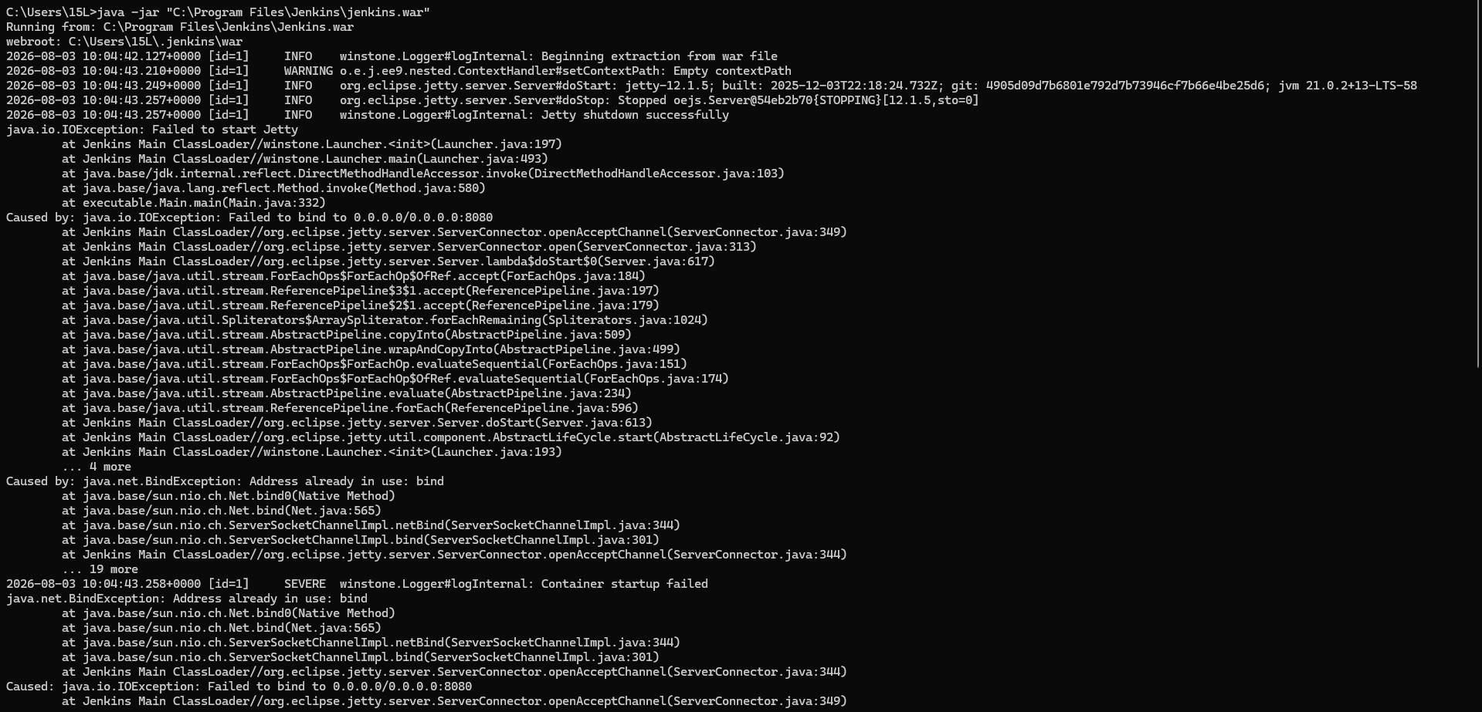
- Navigate to the folder

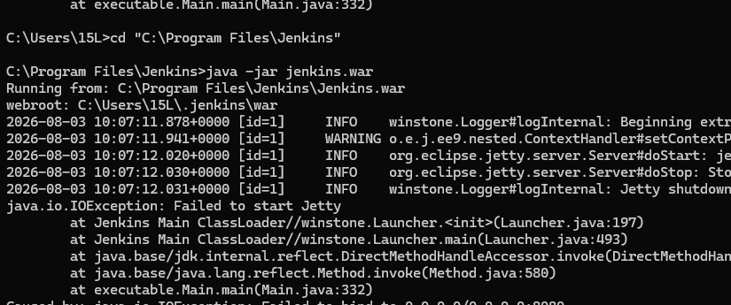

- Start Jenkins: Run the command C:\Program Files\Jenkins>java -jar jenkins.war to start Jenkins server.
- Access Web UI: open localhost 8090

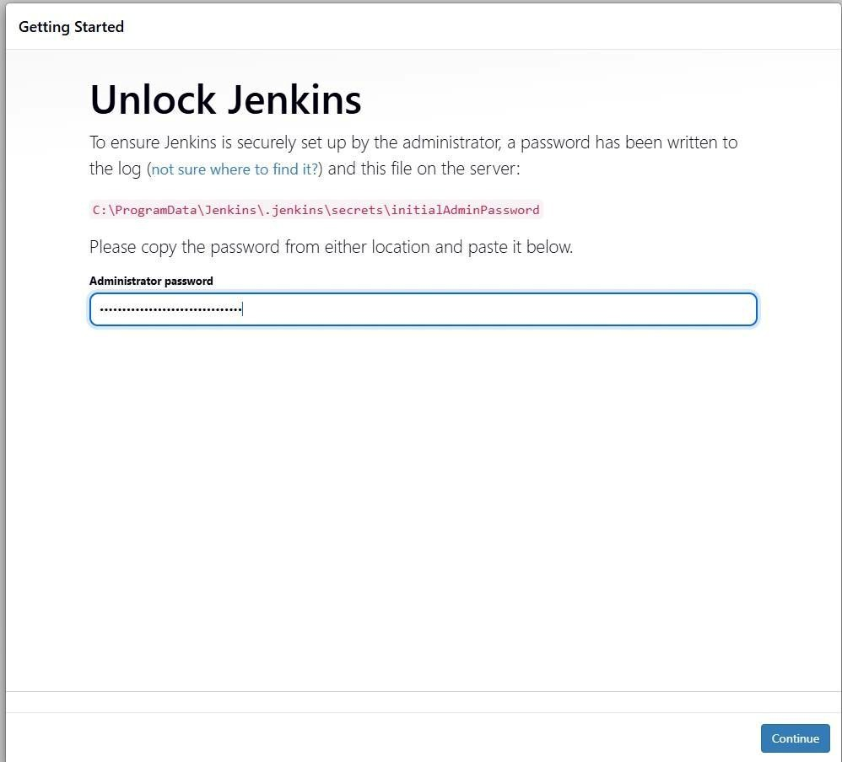

- Open jenkins and pipeline
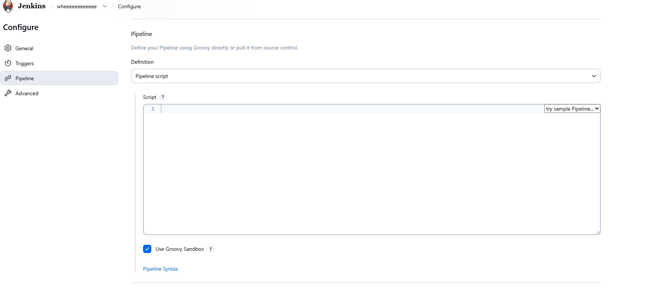

Code:
pipeline { agent any

stages { stage('Hello') { steps { echo 'Hello, Jenkins!'
}
}
}
}

Output:

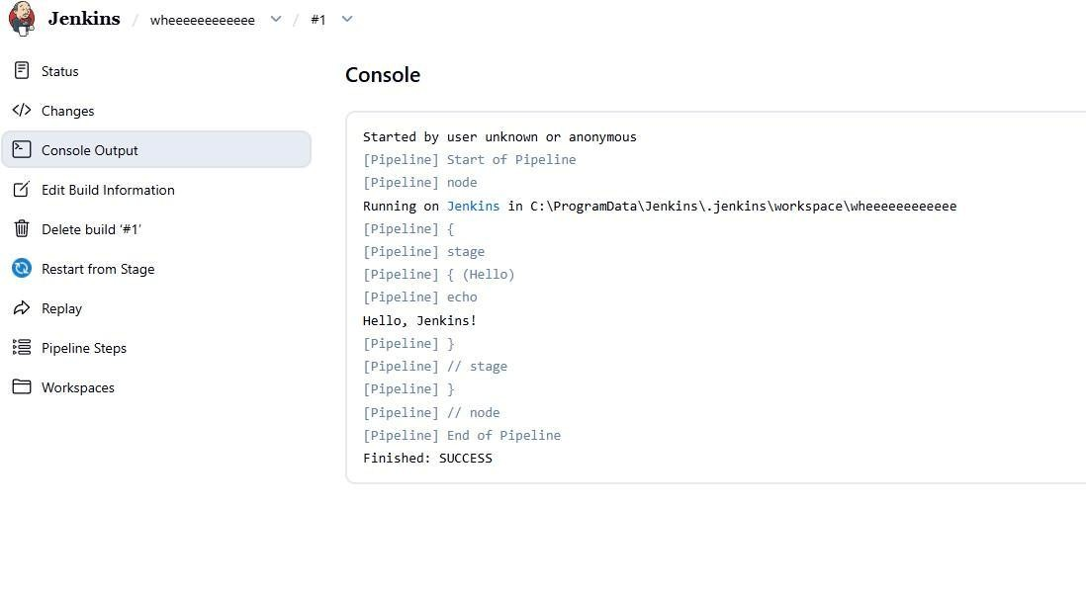
Conclusion:
Jenkins Pipeline automates the software development process by integrating stages like build, test, and deployment to support Continuous Integration and Continuous Delivery. In this experiment, Jenkins was successfully installed and configured by verifying the JDK, launching Jenkins using the jenkins.war file, and accessing the setup page through a browser. A Declarative Pipeline was created and executed, demonstrating how Jenkins automates tasks and improves the efficiency and reliability of the CI/CD process.

